10 Reasons why my child will benefit from a Psychoeducational Assessment:
- The identification of intellectual problems and suggestions of how to address this.
- The diagnosis and treatment of Attention Deficit Hyperactivity Disorder (ADHD).
- If my child has memory problems, he or she will always lag behind their peers in class.
- The identification of learning problems, for instance dyslexia.
- The diagnosing of emotional and behavioural problems.
- The identification of the treatment methodologies to address problems.
- Determining if my child has a superior intellect, or is “gifted”.
- Finding the right programme for a child who might be bored in a main stream school.
- Obtaining special accommodations from the Department of Education for children who write slower than their peer group, battles to put concepts on paper, or needs a scribe for exams.
- You require an overall assessment of your child’s strengths and weaknesses with the necessary recommendations to support your child.
To read the full article, click on the below.
If your child has any of these or other needs, please contact our practice, Dr M C Opperman & Associates Inc, Clinical and Educational Psychologists, where one of our Psychologists will assist you. Please contact us for further information on 011 615 2020 / 011 453 6161 or email us at admin@ianopperman.com.

Reasons why my child would benefit from a full psychoeducational assessment

What is a psychoeducational assessment?
A trained psychologist does a series of standardised assessments with a child with the aim or measuring the child’s cognitive and academic strengths and weaknesses. The child’s ability to memories and pay attention is assessed and measured against their peer group. Generally children are referred for these assessments when they are experiencing difficulties at school, or may be board at school. The aim of the assessment is to provide relevant information from a number of sources, including interview with the parents, the child’s teachers, previous professional and scholastic reports, examples of school work and tests or exam papers, and other role players.
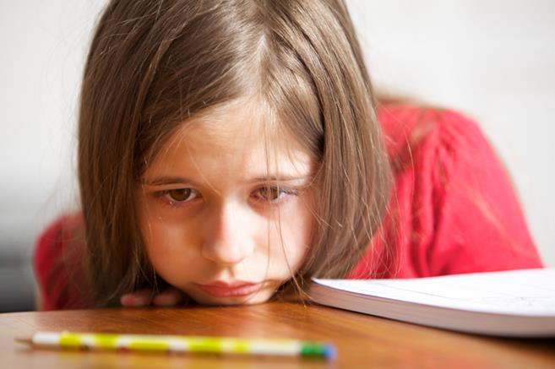
Why might the child require a psychoeducational assessment?
If a child is having difficulty at school, an assessment can identify whether the difficulty is whether their cognitive or intellectual development is delayed or behind that of other children. These include academic skills, like reading, writing, spelling, and mathematics. Unevenly developed academic skills make it difficult for children to perform consistently at school. Awareness of one’s child’s strengths and weaknesses; means that parents and teachers can focus on the accurate skills to address the problem. Problems that might be identified include:
- Intellectual problems: A child might intellectually be on the same level as his /her peers and would battle to keep up with the requirements of the grade that he/she is in. It might be appropriate for a child like this to be put in a remedial school so that their deficits can be accurately addressed, with the aim of reallocating the child to a main stream school once the problems have been addressed.

- Attention and concentration problems: Problems with attention and concentration often relates to Attention Deficit Hyperactivity Disorder (ADHD) which means that the child battled to focus on the class room learning or their homework, and they are easily distracted by extraneous stimuli. There are relatively easy remedies for ADHD, including class room management techniques and discover what distracted the child and eliminating these things. Research shows that if ADHD is not addressed, again the child’s deficit will increase and they will develop a negative attitude toward their academic achievement, fall behind at school, and exhibit behavioural problems. Often ADHD can lead to memory problems.

- Memory problems: If a child battles to remember information at school, acquired from the teacher or learned from their textbooks, they will fall behind their peers in their school work. As learning requires memorising previously learned skills and information, the child’s deficit will increase as the learning becomes more complicated and they will fall back further and further over the years; so it is of utmost importance that it is addressed at an early age.

- Learning problems: If a child does not have an intellectual problem, and yet is struggling to learn, a learning problem could be diagnosed, including dyslexia.

- Behavioural and Emotional Problems: A child or adolescent’s academic difficulties may be due to behaviour, they may be unmotivated to complete school work, misbehaving at school, they might challenge teachers, this behaviour may be due to emotional problems such as anxiety and depression and could relate to family problems. By identifying these problems, the appropriate therapeutic technique could be followed and the problem could be addressed at an early stage before it becomes a permanent situation.

- Superior child (gifted child): superior intelligence or giftedness is when a child performs very well on the intellectual assessment. Often these children do not feel challenged enough by the school curriculum because they are ahead of their peers and will develop problems of boredom and behavioural problems. Again if this is not correctly diagnosed, the child will be treated for the wrong thing.

- Accommodations: if a child has problems, for instance dyslexia, which makes it difficult for the teacher to understand what the child is writing, a special accommodation can be applied for with the Department for Education, for instance for extra time during exams, amanuenses (i.e. scribe or reader), and individual examination as opposed ot being examined within a group.

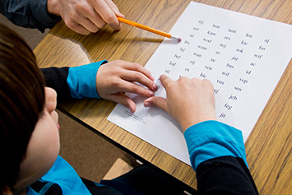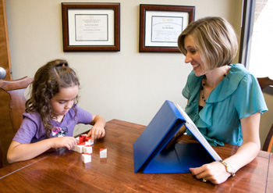
What is the process of assessments?
- An assessment starts with an interview with the parents to gain information about the nature of the presenting problem, the child’s developmental history, the child’s experience in the schooling environment. It is useful to supply the relevant school reports and reports from other professionals consulted and assessments done.
- The assessment occurs with the child with an educational psychologist and is best done in the morning when the child is fresh and more focused as one want to get the best result possible for the child.
- Questionnaires are provided to the teachers to determine how they experienced the child in the school environment and the problems they have identified.
- A comprehensive written report will be provided, as well as a feedback to the parents and the child, should the child be old enough.

Please contact our offices at 011 615 2020 or 011 453 6161 to arrange for a psychoeducational assessment for your child.

